India Government Budget

Government Budget is an itemized accounting of the payments received by government (taxes and other fees) and the payments made by government (purchases and transfer payments). A budget deficit occurs when an government spends more money than it takes in. The opposite of a budget deficit is a budget surplus.
India reported a government budget deficit equivalent to 5.10 percent of the Gross Domestic Product (GDP) in the fiscal year ending March 2011.

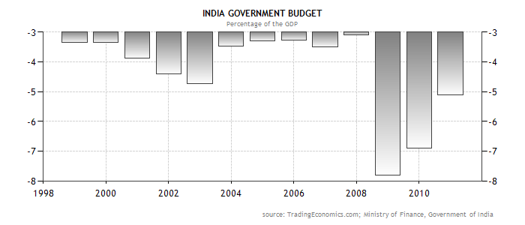

www.stocktradingfundamentals.com

