India Business Confidence

In India, the NCAER (National Council of Applied Economic Research) - MasterCard Worldwide Index of Business Confidence measures the level of optimism that people who run companies have about the performance of the economy and how they feel about their organizations’ prospects. Survey incorporates four indicators: overall economic conditions six months from now, financial position of firms six months from now, investment climate and capacity utilisation level. Data is collected through personal interviews and questionnaires sent to a diverse range of businesses across various regions in India.
In India, business confidence declined to 145.2 in July of 2011 from 145.3 in April of 2011.

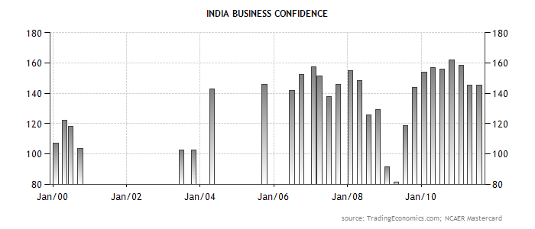

www.stocktradingfundamentals.com

