India Consumer Confidence

In India, the twice annual MasterCard Index of Consumer Confidence analyzes prevailing consumer perceptions of economic conditions for the next six-months. Generally consumer confidence is high when the unemployment rate is low and GDP growth is high. Measures of average consumer confidence can be useful indicators of how much consumers are likely to spend
In India, consumer confidence improved to 75.2 in the first half of 2011 from 73 in the second half of 2010.

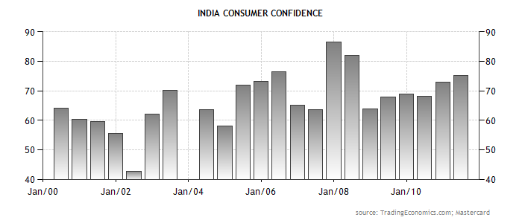

www.stocktradingfundamentals.com

