India Current Account

India reported a current account deficit equivalent to 14.1 Billion USD in the second quarter of 2011. India is leading exporter of gems and jewelry, textiles, engineering goods, chemicals, leather manufactures and services. India is poor in oil resources and is currently heavily dependent on coal and foreign oil imports for its energy needs. Other imported products are: machinery, gems, fertilizers and chemicals. Main trading partners are European Union, The United States, China and UAE

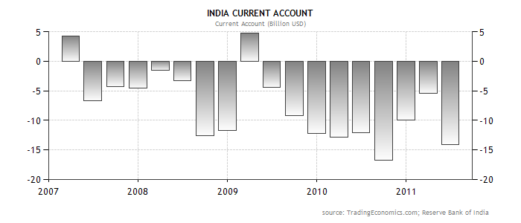

www.stocktradingfundamentals.com

