India Current Account to GDP

The Current Account in India was last reported at -3.2 percent of GDP. From 1980 until 2010, India's average Current Account as percent of GDP was -1.24 percent reaching an historical high of 1.50 percent in December of 2003 and a record low of -3.20 percent in December of 2010. Usually, when India records a strong current account, its Gross Domestic Product expands boosted by exports revenues. Also, India's exchange rate appreciates as investors begin to expect higher interest rates going forward. However, when India reports a stronger than expected current account to GDP, it may also lead to economic overheating and a general rise in prices, also known as inflation, which will make India's products less competitive when sold abroad.

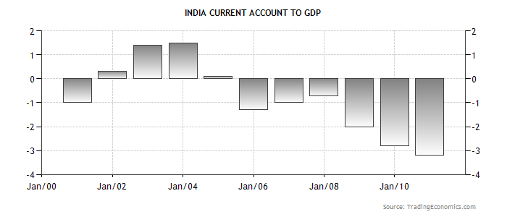

www.stocktradingfundamentals.com

