India Exports

India exports were worth 24821 Millions USD in September of 2011. Exports amount to 22% of India’s GDP. Gems and jewelry constitute the single largest export item, accounting for 16 percent of exports. India is also leading exporter of textile goods, engineering goods, chemicals, leather manufactures and services. India’s main export partners are European Union, United States, United Arab Emirates and China .

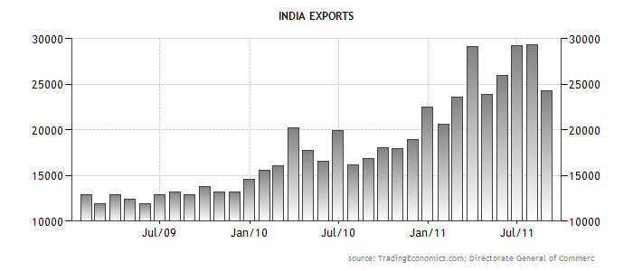

www.stocktradingfundamentals.com

