Government Bonds

A government bond is a bond issued by a national government denominated in the country's own currency. Bonds issued by national governments in foreign currencies are normally referred to as sovereign bonds. The first ever government bond was issued by the English government in 1693 to raise money to fund a war against France. Government bonds are usually referred to as risk-free bonds, because the government can raise taxes to redeem the bond at maturity. Some counter examples do exist where a government has defaulted on its domestic currency debt, such as Russia in 1998 (the "ruble crisis"), though this is very rare. As an example, in the US, Treasury securities are denominated in US dollars. In this instance, the term "risk-free" means free of credit risk. However, other risks still exist, such as currency risk for foreign investors (for example non-US investors of US Treasury securities would have received lower returns in 2004 because the value of the US dollar declined against most other currencies). Secondly, there is inflation risk, in that the principal repaid at maturity will have less purchasing power than anticipated if the inflation outturn is higher than expected. Many governments issue inflation-indexed bonds, which should protect investors against inflation risk. Bonds are issued by public authorities, credit institutions, companies and supranational institutions in the primary markets. The most common process of issuing bonds is through underwriting. In underwriting, one or more securities firms or banks, forming a syndicate, buy an entire issue of bonds from an issuer and re-sell them to investors. The security firm takes the risk of being unable to sell on the issue to end investors. However government bonds are instead typically auctioned. A bond is a debt security, in which the authorized issuer owes the holders a debt and, depending on the terms of the bond, is obliged to pay interest (the coupon) and/or to repay the principal at a later date, termed maturity. A bond is a formal contract to repay borrowed money with interest at fixed intervals. Thus a bond is like a loan: the issuer is the borrower (debtor), the holder is the lender (creditor), and the coupon is the interest. Bonds provide the borrower with external funds to finance long-term investments, or, in the case of government bonds, to finance current expenditure. Certificates of deposit (CDs) or commercial paper are considered to be money market instruments and not bonds. Bonds must be repaid at fixed intervals over a period of time.

Generally, a government bond is issued by a national government and is denominated in the country`s own currency. Bonds issued by national governments in foreign currencies are normally referred to as sovereign bonds. The yield required by investors to loan funds to governments reflects inflation expectations and the likelihood that the debt will be repaid.

www.stocktradingfundamentals.com

India Government Bond 10Y

India's Government Bond Yield for 10 Year Notes rallied 73 basis points during the last 12 months. From 1998 until 2011 India's Government Bond Yield for 10 Year Notes averaged 7.91 percent reaching an historical high of 12.26 percent in February of 1999 and a record low of 4.95 percent in October of 2003.

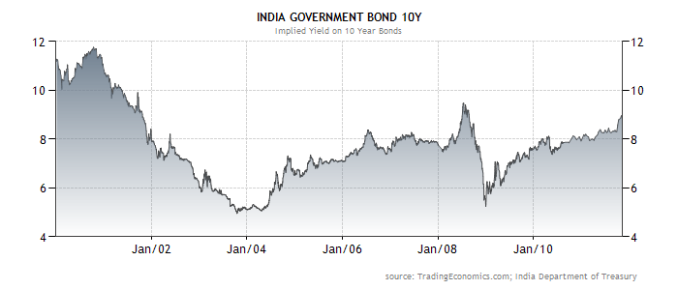

www.stocktradingfundamentals.com

