India Industrial Production

Industrial production measures changes in output for the industrial sector of the economy which includes manufacturing, mining, and utilities. Industrial Production is an important indicator for economic forecasting and is often used to measure inflation pressures as high levels of industrial production can lead to sudden changes in prices. Industrial Production in India expanded 4.1 percent in August of 2011. From 1994 until 2010, India's industrial production averaged 7.49 percent reaching an historical high of 17.70 percent in December of 2009 and a record low of -0.20 percent in December of 2008.

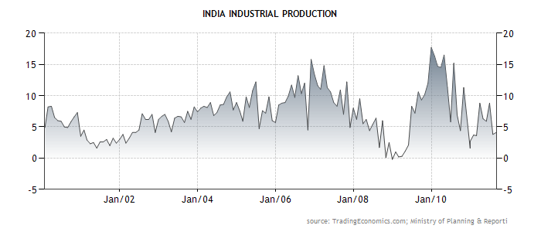

www.stocktradingfundamentals.com

